# verview

In this guided practice, you will create the topology required for your course.

# Objectives

* Be able to create a virtual machine in Hyper-V.
* Be able to add a disk to a virtual machine.
* Be able to create a differencing disk using Hyper-V.
* Be able to create a virtual switch using PowerShell.

# Prerequisites

Windows 10 or Windows Server physical or virtual machine with virtualization enabled and Hyper-V installed.

# Tasks

This course requires five virtual machines, two client machines with the Windows 10 operating system installed and three Server virtual machine with Windows Server 2019 installed. You will create these virtual machines using a script provided by your instructor.

## SERVER CONFIGURATIONS

In this section, you will configure additional settings to support the class exercises.

### NETWORK CONFIGURATION

1. Login to the VCASTLE virtual machine using the **Administrator** account with a password of **Password1**.
2. Rename your adapters to **LAN1** and **LAN**.
3. Disable the **LAN1** adapter.
4. Verifyyour network settings and that your virtual machine can reach the **Internet.**
5. Rename your computer to ***Lastname*-VM-Host**. Where ***Lastname*** is your last name. So, if your last name was **Frederick**, your computer should be named **Frederik-VM-Host**.

### USABILITY SETTINGS

(Some of this stuff you would not normally do but it is okay in the guided practice because they speed things up)

1. **Disable** and **stop** the **Windows** **Update** service

### Manageability Settings

1. **Update** **PowerShell** **help** 
   1. Open elevated **PowerShell** session and type **Update-Help** (you need an Internet connection).

**Note:** Expect a couple errors with updating modules.

1. Updatethe **Pester** Module using the following command:

Update-Module Pester –Force

1. Close the **PowerShell** window and then open elevated **PowerShell** session.
2. Verify you have the correct version by typing the following:

Get-Command –Name Invoke-Pester

1. 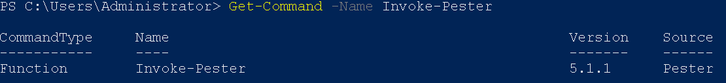You should see the output shown below. You will need at least version 5.1.1 for the grading scripts to work.

## CONFIGURING WINDOWS SERVER 2019 AS A VIRTUALIZATION SERVER

To enable virtualization, on a Windows Server you need to install the Hyper-V role. To do this, perform the following:

1. On your **VCastle** **virtual** **machine**.
2. Verify **Hyper-V** is installed:
   * 1. **Open** an **elevated** **PowerShell**.

Get-WindowsFeature -name Hyper-V

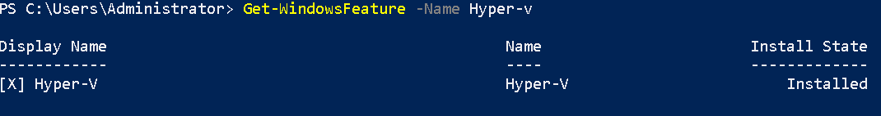

1. Pin the **Hyper-V Management** console to the **taskbar.**
2. Create the following **folders** on the **D:** drive:
   1. **D:\VM**
   2. **D:\VHD**
3. Configure the following **Hyper-V settings**:
   1. Virtual Machine Storage – **D:\VM**
   2. Virtual Hard Disk Storage – **D:\VHD**
   3. Enhanced Session Mode Policy – **Allow Enhanced Session Mode**
   4. Enhanced Session Mode – **Use Enhanced Session Mode**

## Create the LaB Network

1. Download and run the **Create-CIS256-Topology** Script from the assignment page.
2. The script should create the virtual machines and switches shown in the diagram below and connect the virtual machines to the appropriate switches.

## Configure the Virtual Machines – General guidance

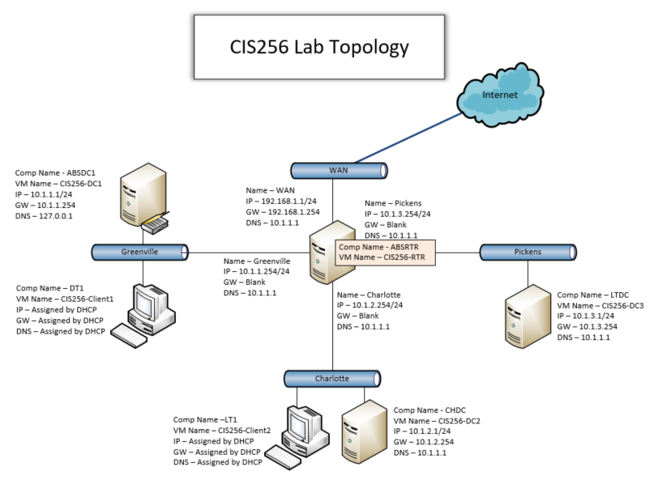Whenconfiguring the network settings for **virtual machines** use the information in the topology diagram shown **below**:

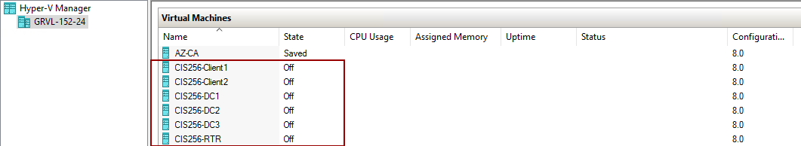You should have the following virtual machines when you are done.

All the images have had sysprep run on them. Start the virtual machines and run through the OOBE setup using the following settings:

1. Windows Server virtual machines:
   1. Skip the Product key
   2. Administrator password: **Password1**
2. Windows Client virtual machines:
   1. Skip the Product key
   2. Initial user account:
      1. Username: **Student**
      2. Password: **Password1**
   3. Skip the network setup

## Configure the router virtual machine

1. **Open** the **settings** for the **CIS256-RTR** virtual machine and **verify** that 4 **network** **adapters were configured as follows:**
   1. An **adapter** connected to the **Wan** switch.
   2. An **adapter** connected to the **Greenville** switch.
   3. An **adapter** connected to the **Charlotte** switch.
   4. An **adapter** connectedto the **Pickens** switch.

## Configure the CIS256-RTR virtual machine

Start the **CIS256-RTR** virtual machine and configure the following:

1. Computer Name: **ABSRTR**
2. **Set** the **administrator** **password** to **Password1.**
3. Do not set the product key yet.
4. 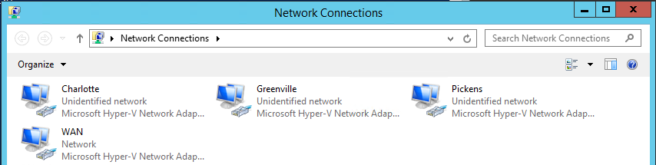**Rename** the **Network Adapters** so that they have the same name as the switch to which they are attached. You can identify the adapters by disconnecting them from their virtual switches one at a time and see which network connection indicates it is disconnected.
   1. Open Router VM and click on Local Server in Server Manager on the Ethernet cards in Server Manager (you should see 4 NIC cards- See screenshot below) Drag the Nic cars over to the right of the screen.
   2. **Click on file/Settings** (See below) and place both screens on desktop.

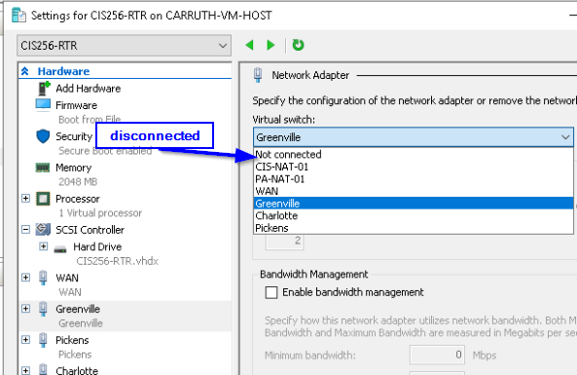

* 1. **Highlight the first NIC card** in Settings (ex. WAN) and click the down arrow at top of the right screen and choose **Not Connected**. Then click Apply at bottom.
  2. You should see one **NIC card with an red X** on it. **Rename this card** per the switch name (ex. WAN). Adjust the TCPI/IP settings per the drawing in assignment**. Connect the Switch** back to the correct switch (ex. WAN) and click **Apply**. The red X on the NIC Card should disappear.

1. Do the same with the other NIC cards and **configure** the adapter **TCP/IP** settings as shown on the **diagram** above. The router interfaces do not have a gateway addresses.
2. Verify that you can **ping 1.1.1.1**. If this does not work, see the Other Router Configuration below.
3. **Save** the **state** of your virtual machine.

## Configure the CIS256-DC1 virtual machine

Start the **CIS256-DC1** virtual machine and configure the following:

1. Computer Name: **ABSDC1**
2. **Set** the **administrator** **password** to **Password1.**
3. Do not set the product key yet.
4. **Rename** the **network adapter** to **LAN**
5. **Configure** the adapter **TCP/IP** settings as shown on the **diagram** above.
6. **Verify** that you can **ping** your gateway. **Hint:** You will need to enable a firewall rule on **CIS256-RTR** to allow ICMP.
7. **Save** the **state** of your virtual machine.

## Configure the CIS256-DC2 virtual machine

Start the **CIS256-DC2** virtual machine and configure the following:

1. Computer name: **CHDC**
2. Set the administrator password to **Password1.**
3. Do not set the product key yet.
4. **Rename** the networkadapter to **LAN.**
5. Configure the adapter TCP/IP settings as shown on the **diagram** above.
6. **Verify** that you can **ping** your gateway**.**
7. **Save** the **state** of your virtual machine.

## Configure the CIS256-DC3 virtual machine

Start the **CIS256-DC3** virtual machine and perform the following:

1. Computer Name: **LTDC**
2. **Set** the **administrator** password to **Password1**
3. Do not set the product key yet.
4. **Rename** the networkadapter to **LAN.**
5. **Configure** the adapter **TCP/IP** settings as shown on the **diagram** above.
6. **Verify** that you can **ping** your gateway**.**
7. Save the state of your virtual machine.

## Configure the CIS256-Client1 virtual machine

Start the **CIS256-Client1** virtual machine and configure the following:

1. Computer Name: **DT1**
2. Save the state of your virtual machine.

## Configure the CIS251-Client2 virtual machine

Start the **CIS256-Client2** virtual machine and configure the following:

1. Computer Name: **LT1**
2. Save the state of your virtual machine.

## Other Congifurations needed on Router VM

1. Open a **PowerShell(Admin)** window and ping each of the 4 interfaces ex. Ping 10.1.2.254.
2. Open the Firewall by typing in the magnifying glass on taskbar.



1. Click on **Inbound Rules** in left column and enable the File and Printer Sharing(Echo Request). Right clicking on rule and click Enable rule.



1. All 3 servers must have the same Firewall rules enabled.

## Submission Requirements

1. **On** your **VMHost** system**, create** a **folder** in the root of your **C:\** named **Scripts**. Log into Canvas and access this course. **Download** the **grading** **script** from the assignment page to the **C:\Scripts** folder.
2. Check your lab by running the following command:

Invoke-Pester -Path C:\Scripts\GP01-Computer_Setup.test.ps1

**Note**: You will see a security warning when running the script. Enter **R** to run the script.

If you want to see more detail, add **-Output Detailed** to the command. This may assist you with troubleshooting

Invoke-Pester -Path C:\Scripts\GP01-Computer_Setup.test.ps1 -Output Detailed

1. You should not see any red in the output. Red in the PowerShell way of telling you that an error condition exists. Most of the time, the output will tell you what is wrong. If it is not obvious, contact your teacher and ask for assistance. You will be learning PowerShell during this term. **Correct** any **errors** you may have and run the script until all the output has no red. You should see the output like the images below.

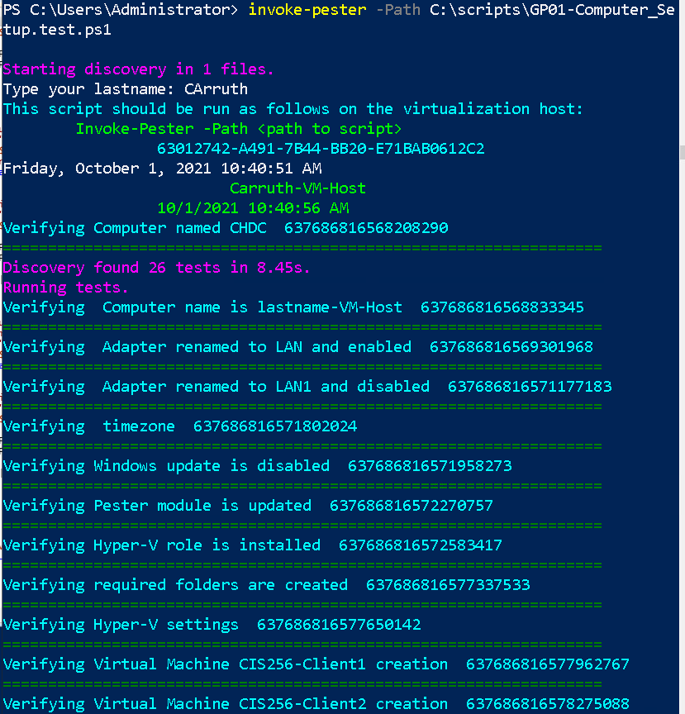

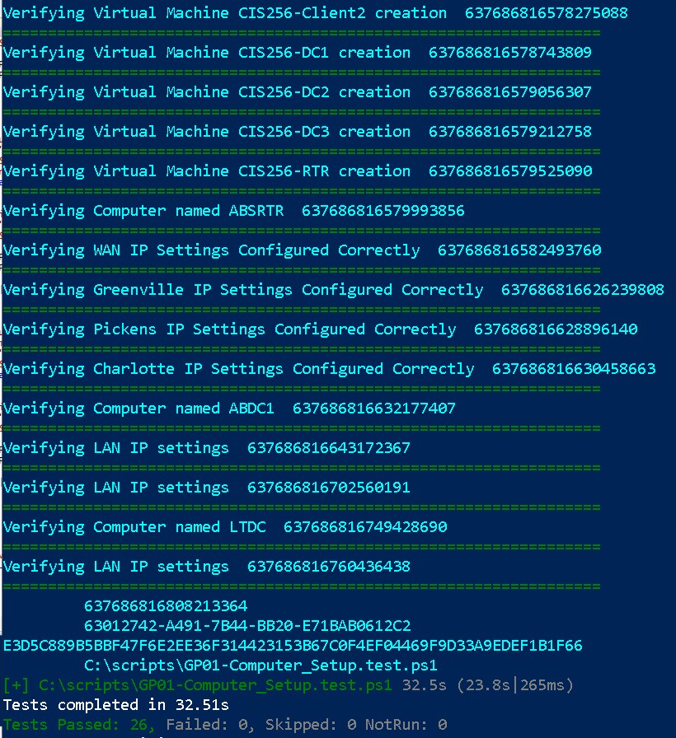

1. Capture a snippet that shows the PowerShell Command and all its output. If you must use more than one snippet to capture the output, you must have at least **one line of overlap** in the snippets. The text in the snippets **must be legible** when pasted into the Word document. Paste the snippet(s) into a **new** **Word** **document.**
2. **Upload** the **document** in the submission area for the assignment.